System Analysis & Design

on

Online Learning Platform

eLearn.com

Instructor:

Md. Ashfaqul Islam Tonmoy

Dhaka International University

Analyst

Shuvongkor Barman

Roll: 38 CSE-E59, 8th Semester

Dhaka International University

|  |  |
| --- | --- |
| Table of Contents |  |
| Name | **Page No** |
| Introduction | 3 |
| Sample eLearn Homage | 4 |
| Required Features | 5 |
| Feasibility Study | 17 |
| System Requirements | 24 |
| Data Flow Diagram | 26 |
| Process Specification Structured English, Decision Table, Decision Tree | 35 |
| Conclusion | 48 |

**Introduction**

Education is the backbone of a nation. Learning is the only way to develop anything. There is so many schools and universities providing the opportunity to learn and develop skills that will help people grow and live a happy life.

But it is not sufficient, not everyone gets this opportunity, nor the schools or universities are successful in teaching everyone.

That is why we need a learning system that will give everyone the opportunity to learn and teach.

We want a learning system that will give people the option to learn or teach from anywhere and anytime.

eLearn is such a learning system that provide people the option to learn and teach from anywhere and anytime.



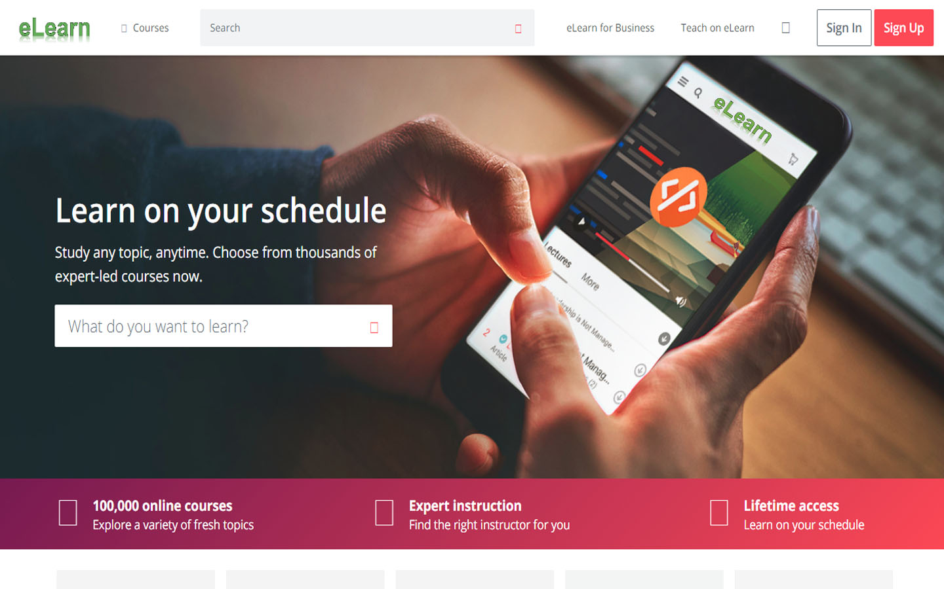

Figure: **Sample eLearn Homepage**

**Required Features**

1. **Registration**

People should be able to sign up as a learner or teacher. A registration features allows people to do just that by filling out necessary information like username, password, email etc. After finishing signing up people can sign in anytime using the username or email and password to enter in the eLearn system.

Registration form must have the following options:

✔ Username

✔ Email

✔ Password

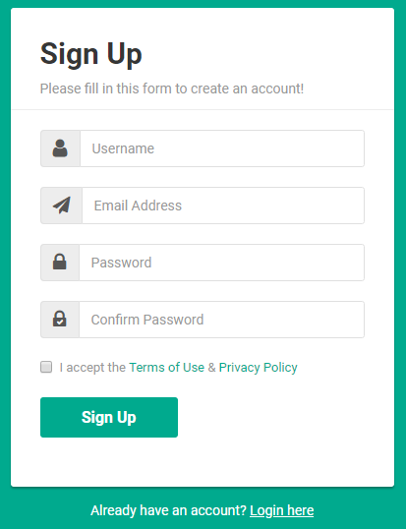✔ First Name

✔ Last Name

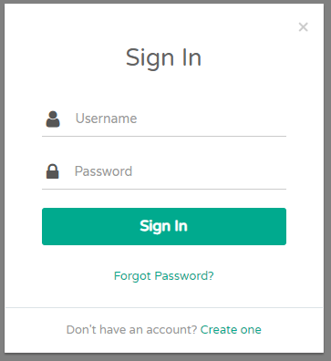

Figure**: Sample Sign In & Sign Up Form**

1. **Users Profile**

People who sign up successfully both as learner or teacher and able to sign in into the eLearn System should have a user profile features where people can store their profile information. They should be able to share their profile to other learners or teachers. User profile should include all badges and record of all exam that a learner or teacher has passed with the score.

User Profile must have the following options:

✔ Personal Information

✔ Educational Information

✔ Social Networks Links

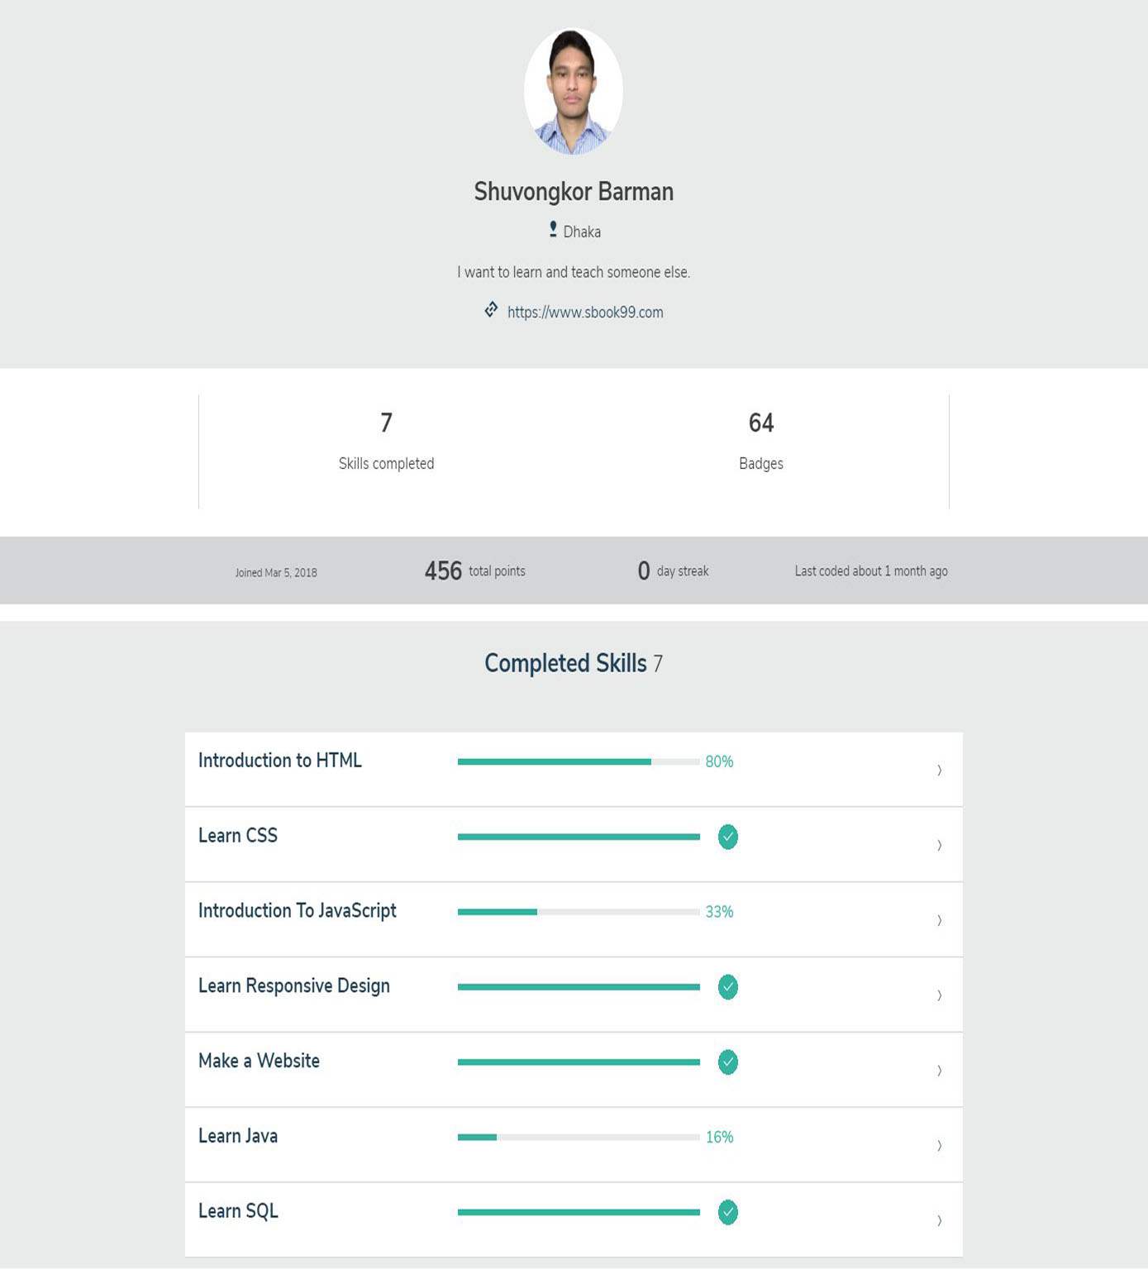✔ Earned Badges and Passed Exam Score

Figure: **Sample User Profile**

1. **Learner Portfolio**

Leaners will pass many tests after finishing some course and they will obtain certificates. This certificate should be automatically added to their Learner Portfolio. They should also be able to add other certificates manually. Learners will work on various projects after they finished some course. This project should be saved and show in the Learner Portfolio. They can make as many projects as they want and include in their Learner Portfolio. They can also include project that they have learnt from somewhere else and done somewhere else.

Learner Portfolio must have the following options:

✔ Adding Certificates

✔ Adding Project

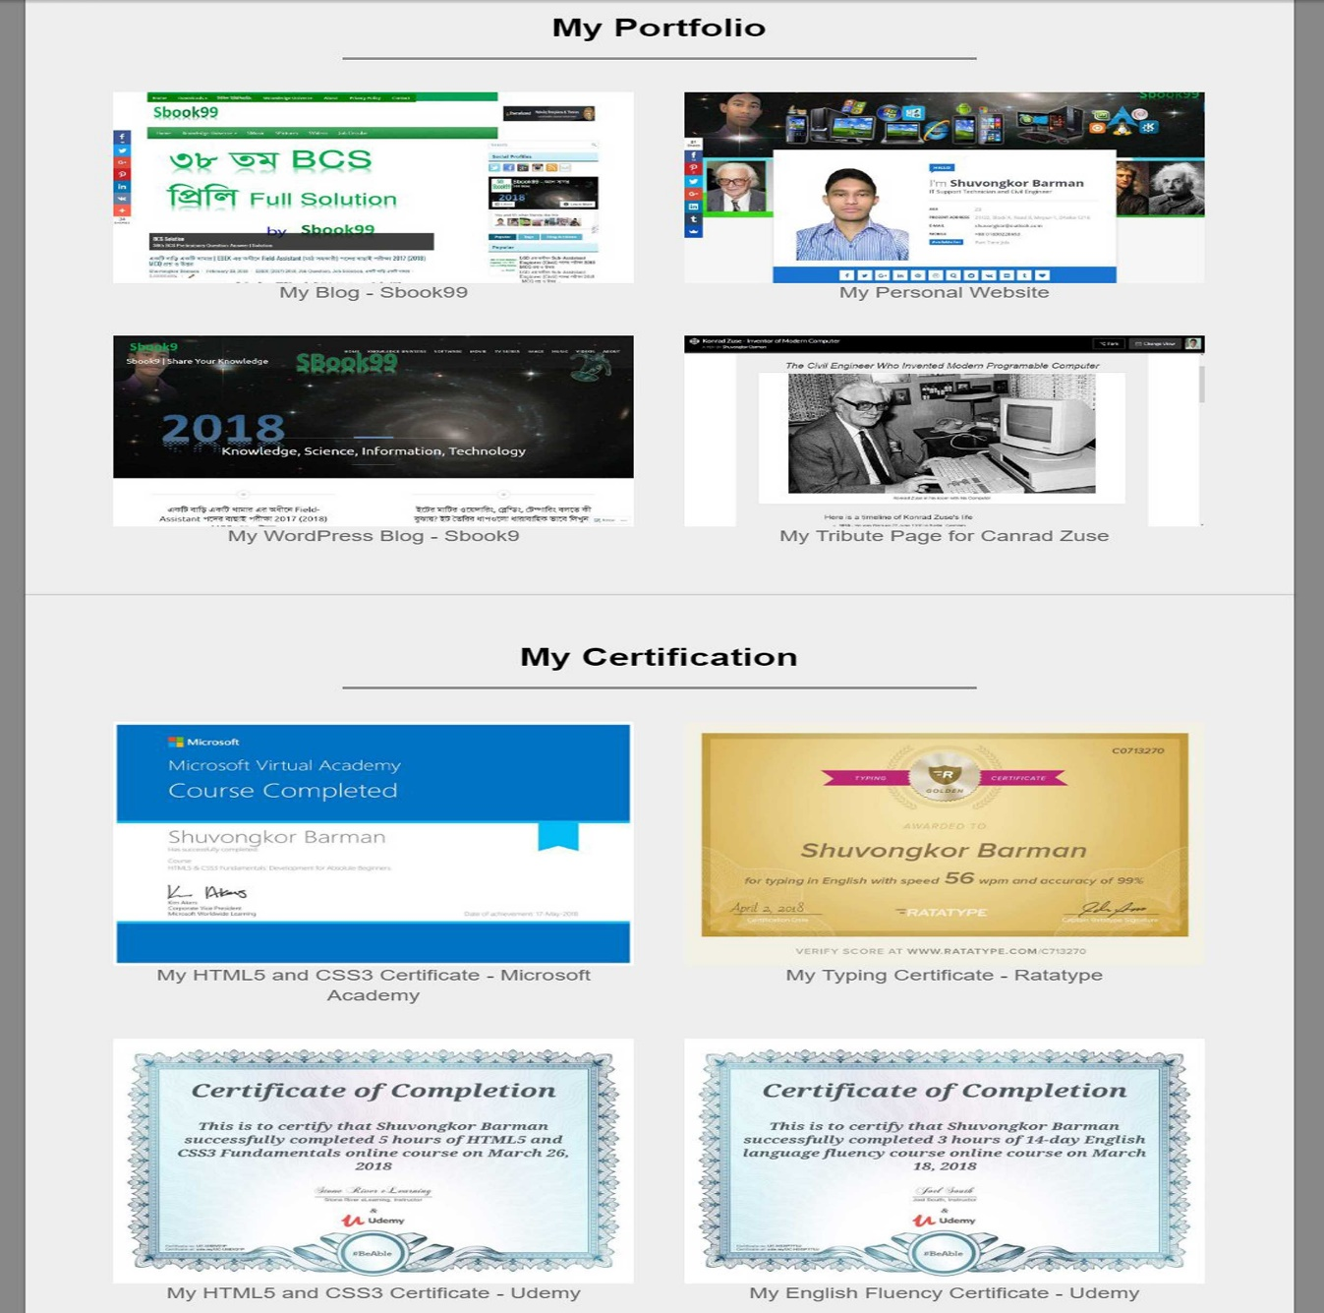

Figure: **Sample Learner Portfolio**

1. **Teacher Portfolio**

Teacher must pass at least one test in order to became a teacher after finishing sign up process as a teacher. After that they can pass as many tests as they want. The tests are for specific course that they want to teach.

After passing each test they will obtain certificates. This certificate should be automatically added to their Teacher Portfolio. They should also be able to add other certificates manually. Teacher will work on various projects during teaching a course. This project should be saved and show in the teacher Portfolio. They can make as many projects as they want and include in their Portfolio. They can also include project that they have learnt from somewhere else and done somewhere else.

Teacher Portfolio must have the following options:

✔ Adding Certificates

✔ Adding Project

1. **Course Creation**

Teachers should be able to create courses that they want to teach. Course creation feature will do just that. They should be able to upload videos or other files relevant to their courses.

Course Creation feature must include the following options:

✔ Course Name

✔ Course Topics

✔ Course Duration

✔ Course Price

1. **Course**

Learners should be able to see all the available courses using an option called Course.

Couse feature must have the following options:

✔ Group by Subject

✔ Free Courses

✔ Paid Courses

✔ Top Rated Courses

✔ Most Learned Courses

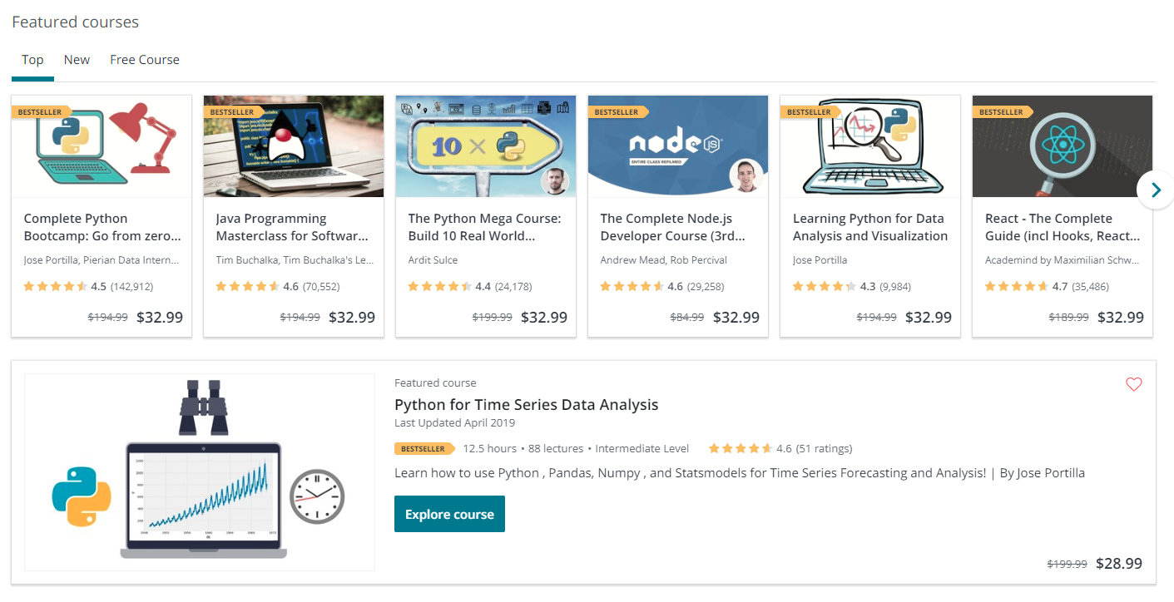

Figure: **Sample Course Menu**

1. **Search**

Learners should be able to find the course they want to learn using an option called Search.

Search features must include the following options:

✔ Filter

By

✓ Free Course

✓ Top rated Course

✓ Last Added Course



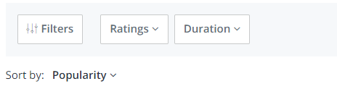

Figure: **Sample Search and Filter By**

1. **Lecture**

Teachers should be able to share their lecture using this feature and Learners should be able to watch and download those lectures from here. This lecture can be either free or paid.

Lecture features must include the following options:

✔ Free Lectures

✔ Paid Lectures

✔ Top Rated Lectures

✔ Most Viewed Lectures

1. **Downloads**

Users should be able to able to download any video lectures or files from eLearn.

Download features must include the following options:

✔ Downloading Video Files

✔ Downloading Audio Files

✔ Downloading PDF Files

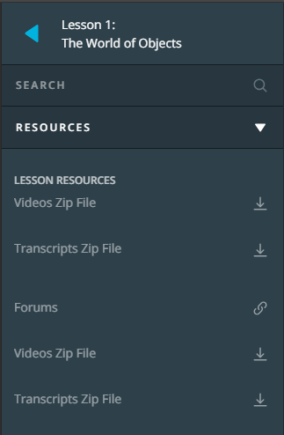

Figure: **Sample Download Option**

**10. Notification**

Users should get all notification about their activity and other relevant messages for example earing a badge, earning a high score, passed a test, earn a certificate, teachers’ message, learners’ messages etc.

Notification features must include the following features:

✔Remove Notification

✔Mark Notification

✔Mark All as Read

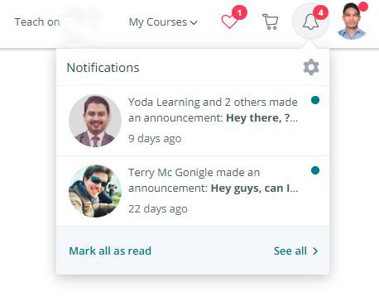

Figure: **Sample Notification Fature**

**11. Gamification**

Gamification is a feature that will help the learners learn in a gaming way and achieved their goal. Every course will contain some badges, points. There will be certain levels that Learners can achieve by earing points and badges. Teacher can also earn points and grow their levels.

This feature will make eLearn is like playing a game. Learning while having fun.

Gamification feature must have the following option:

✔ Earn Points by Learning

✔ Earn Points by Passing Tests

✔ Earn Points by Making Projects

✔ Earn Points by Solving Problems

✔ Earn Badges by Completing Courses

✔ Level Up

✔ Ranking System

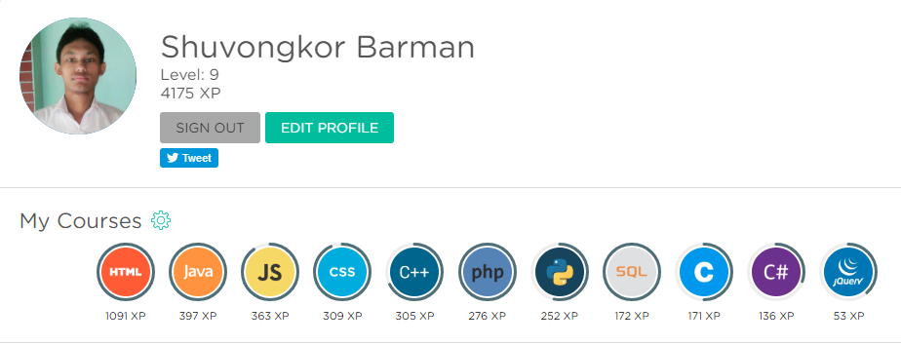

Figure: **Sample Gamification System**

**12. Testing and assessment**

Test and assessment are an essential part a learning system. Learners should be able to test their knowledge through some test and assessments. This will help improve their skills and knowledge. This will also improve learners confident in themselves.

Testing and assessment must include the following features:

✔ Take Tests

✔ Complete Assessment

✔ Retake Test

**13. Certification**

Certification is a feature that is essential for an Online Learning System. This feature will enable the Learners to obtain a certificate after finishing a course successfully. Learners will be able to share their achievement to their friends. This will also help them for future development of their learning life.

Certification feature must have the following option:

✔ Download Certificate as PDF  
✔ Download Certificate as Image

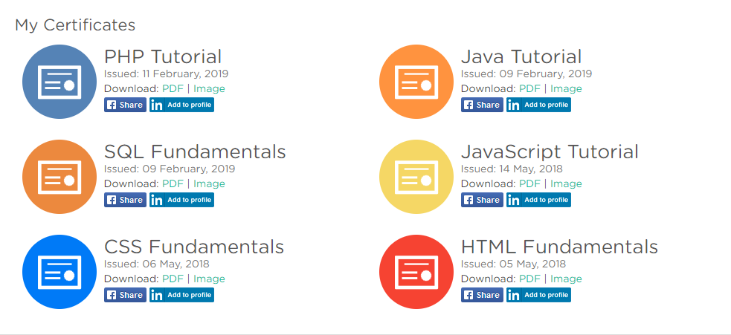✔ Share Certificate

Figure: **Sample Certification System**

**14. Free eBook**

Learners should be able to download and read free eBook from eLearn for better learning experience. Teachers should be able to upload free eBooks to the eLearn system.

Free eBook feature must have the following option:

✔ Download as PDFs

✔ Read Online

✔ Add to Favorite

**15. Mobile Learning**

eLearn should have the feature mobile learning which mean eLearn should run on mobile devices. So that learners can continue learning in their mobile devices even if they started learning from a computer**.**

**eLearn** website will be fully responsive. It will automatically fit across all kind of devices.



Figure: **Learning on a Mobile Device**

**16. Discussion Forum**

A discussion forum is needed for the learners and teachers to discuss about learning things. Learners should be able to share their problems in the forum and get help from the forum community.

Discussion Forum should have the following options:

✔ Upload Screenshot of the Problem

✔ Ask Solution

✔ Provide Solution

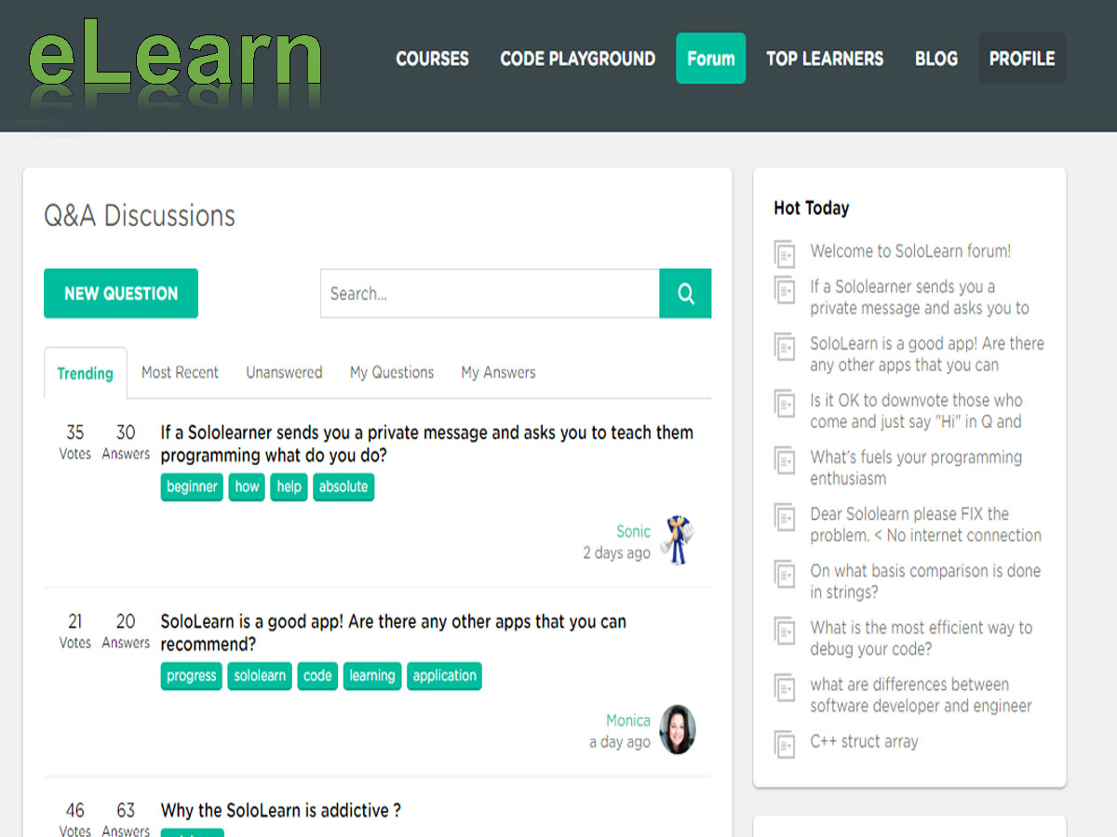

Figure: **Sample Discussion Forum**

**Feasibility Study**

**Problem Analysis**

**Current System:**

The current system of education and learning is very limited. It has limitation of resources. Students all over the world are not getting enough opportunity to get knowledge. They only learn from the lecturer’s lectures, books that are given to them. This is very unfortunate that student only get knowledge from lectures in class. And all student can not join all class all the time. Which is a major problem for those who are unable to join every class.

Here are some of the major problems found in the current system:

➡ The current system at a university or school does not have the features of downloading lectures or lecture references for student or for teacher.

➡ Students only have the option for submitting assignment through hard copies which is a waste of paper.

➡ Students only get help from lectures in a single university.

➡ Students learn from very limited number of teachers.

➡ Students must be physically present in the classroom in order to gain knowledge, there is no other way.

➡ Students are unable to share resources effectively and hold group discussions that are monitored or supervised by lecturers.

➡ The current system at a university is very limited to its own area or country, it can not help students far away, or student that lives in other country.

➡ Student have to buy physical books while studying in the current system at a university which is costly.

➡ Student has to pay a lot of money in order to obtain a certificate, which is not possible of everyone.

**The Future System:**

The future system eLearn will hopefully solve most of the problem of the current system. Students all over the world will be able to learn through the eLearn system and teacher will be able to teach student all over the world. No one have to worry about the learning place, because it is virtual and everyone can use it through the internet. Users will be able to communicate and share necessary information anytime and from anywhere using the future system.

Here are some expected results of the future system:

**✓** Users will be able to download lectures or other education resources both for learning and teaching.

**✓** Students will be able to submit assignment online directly.

**✓** Teacher from all over the world will be able to teach through the eLearn system.

**✓** User don’t have to be physically present to gain knowledge because the system is virtual.

**✓** Student who lives far away or even in other country will not matter.

**✓** Students will not have to buy physical books, eLearn System will provide eBook download option for free or at a cheap price.

**✓** Student will be able to obtain a certificate for free by passing the test and summitting assignment.

**✓** Learner all over the world will be able to share their ideas and thoughts and communicate with each other and help each other.

Objective of The Project

E-Learning represents an innovative shift in the field of learning, providing rapid access to specific knowledge and information. It offers online instruction that can be delivered anytime and anywhere through a wide range of electronic learning solutions such as Web-based courseware, online discussion groups, live virtual classes, video and audio streaming, Web chat, online simulations, and virtual mentoring. E-Learning enables organizations to transcend distance and other organizational gaps by providing a cohesive virtual learning environment. Companies must educate and train vendors, employees, partners, and clients to stay competitive and E-Learning can provide such just-in-time training in a cost-effective way. Developing and deploying effective E- Learning programs may require products and services supplied by a variety of vendors, leaving

one to connect the dots. One way to start is to define the goals of the desired learning solution.

Definition of the goals of an E-Learning solution is driven by the following factors:

**➡ To perform task analysis**

Determine the tasks to be taught, identify subtasks and other elements involved, and identify the knowledge, skills, and attitudes required to complete the tasks efficiently and effectively.

**➡ To perform training needs analysis**

Identify the target audience for the training. Identify the shortfall in knowledge, skills, and attitudes of this audience and determine what the target learners need to know.

**➡ To review existing capabilities**

Review existing methods and infrastructure for providing training or meeting learning needs.

**➡ To determine expectations**

Identify concrete expectations and/or ROI requirements from the desired E-Learning solution. The development of an E-Learning strategy begins by setting goals. What will the E-Learning strategy accomplish? Without a true understanding of the goals of the E-Learning strategy, it will be difficult, if not impossible, to be successful.

Before implementing E-Learning, organizations need to set common goals or objectives.

Common goals and objectives include the following:

**➡ To reduce learning costs**

As a small business owner, you know that online transactions cost a fraction as much those requiring paper or staff. It’s the same with E-Learning because there are no papers, no delays, and no travel expenses. Such learning enables employees to take what they have just learned from their computer screens and apply it to the tasks at hand.

**➡ To motivate employees**

E-Learning is considered an effective way to keep up with new technology, to generate new ideas, and to keep your workforce fresh and inspired.

**➡ To improve flexibility of course delivery**

Smaller businesses don’t have the staff to manage their training and development initiatives. E-Learning technologies can overcome these administrative restrictions

**Significance of e-Learn System**

Technology has the power to transform the current education system to a better one. It is very important that learner get as many options as they need to learn something.

Here are some of the reasons (significance/importance):

1. Students need to be engaged with what they are doing to improve learning outcomes

2. It enables students to become thinkers/learners/risk takers in a better learning environment.

3. Learn not to rely on the teacher…be accountable themselves…become independent!

4. Broadens the horizons of many students as it exposes students to the world outside their city or even country.

5. Fits in with Rural Education where students in small rural schools need no longer be disadvantaged by distance and isolation, as technology allows them to learn virtually and maintain their subject choices, allows e.g. LOTE (languages other than English) and other specialist subjects to be taught across schools by a virtual teacher and virtual learning system.

6. Allows a mobile learning environment – anywhere, anytime.

7. It enables anyone with the skills to became a teacher, it does not matter where he/she is, or who is he/she.

8. It enables student to learn for free or at a cheap cost.

**Delimitation and Scope of Study**

Although e-Learning has many benefits for students and organizations alike, it also has limitations.

Here are some of the limitation that we should mention:

◈ **Computer literacy and access to equipment.** Any e-Learning system involves basic

equipment and a minimum level of computer knowledge in order to perform the tasks required by the system. A student that does not possess these skills, or have access to these tools, cannot succeed in an e-Learning program.

◈ **Some topics are not appropriate for e-Learning**. Certain subjects that require physical exertion and practice, such as sports and communication skills, are not good candidates for e-Learning. However, e-Learning can be a useful companion to traditional education for teaching background and technical information.

◈ **Students themselves can be a limitation to e-Learning**. The flexibility and student-centered nature of e-Learning requires a high level of student responsibility. A successful e-Learning student must be well organized, self-motivated, and have good time management skills. What you get out of an e-Learning program is directly related to the amount of effort you put in.

**Best Learning Management System Defined**

• **Cost effectiveness:** the total cost figures included in this report represent a current snapshot of the LMS expenditures excluding self-hosting and migration cost, is reported to the Assessment team. The benefits of the LMS is expected to be more than cost such as hosting maintenance and other cost that may be incurred.

• **Support and Training:** the system must have a virtual learning community provides students orientates templates and professionals, development resources for faculty by providing online help desk services for students and faculty that includes chat, email, telephone and a personalized support portal available 24/7/365.

• **Ease of Use:** the LMS must have ease of use components and no additional instrument questions were developed the system should have a higher level of instructor and administrator perceived application functionality.

• **Scalability:** the LMS must be able to report on the number of active courses, users, and average course size and storage capacity on their LMS. It should be able to hold a lot of actives but still be able to use a less storage capacity.

• **Sustainability:** The sustainability of an LMS is paramount to the future growth of distance learning in the university. The system-wide capability to support LMS-centric learning technology is challenging in both the short and long terms. Information from the success NC listening tour notes indicate that: -

(1) Colleges differ on LMS preferences but want continued support from the System Office.

(2) Learning technology offers an effective and flexible means to facilitate learning.

(3) Increased enrollments have negatively affected instructors, strained facilities, and encouraged creative interventions to maximize resources.

**System Requirements**

**Requirement for running or using the System:**

✔ PC/Mobile/Tablet

✔ Internet

Minimum Hardware Requirements:

✔ 1 GB RAM

✔ 1 GHz Processor

✔ 720p Resolution Display

✔ Mouse

✔ Keyboard

✔ Touch Capability [For Touch Devices]

Since, **eLearn** is an online Web-Based Application Software a user only needs a PC or Mobile device or any other device that can runs a Web Browser and internet connection.

✔ All Web Browser with HTML5 & JavaScript support.

**Recommended Browser:**

✔ Firefox

✔ Google Chrome

✔ Microsoft Edge

**Requirements for Developing the System:**

**Language/Technology:**

✔ HTML5

✔ CSS

✔ JavaScript

✔ Node.js and Express.js

✔ Git + GitHub

**Database:**

✔ PostgreSQL and MongoDB

**Local Development Environment:**

✔ XAMPP

**Browser:**

✔ Chrome, Firefox

**IDE:**

✔ Visual Studio Code

✔ Atom

**Machine:**

✔ Windows 10 Desktop PC

**Budget**: 10 million US Dollar

**Time:** 1 Year

**Project Start Date:** 01/01/2100

**Project End Date:** 01/01/2101

Data Flow Diagram

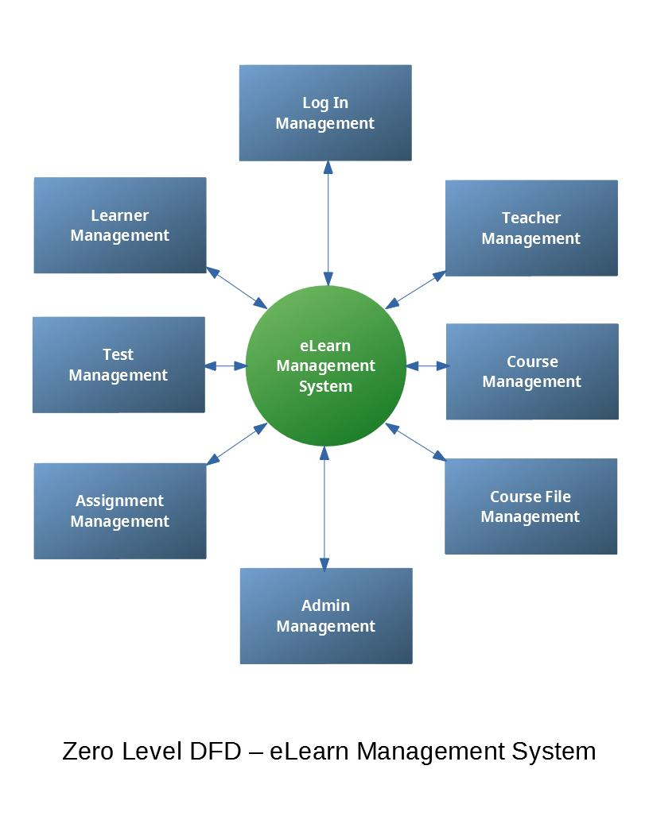

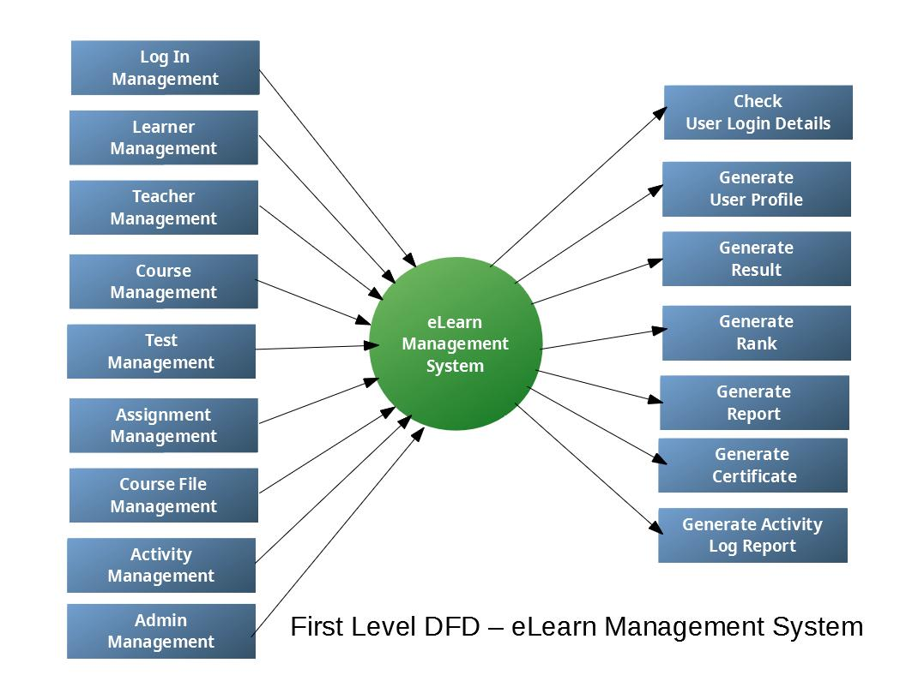

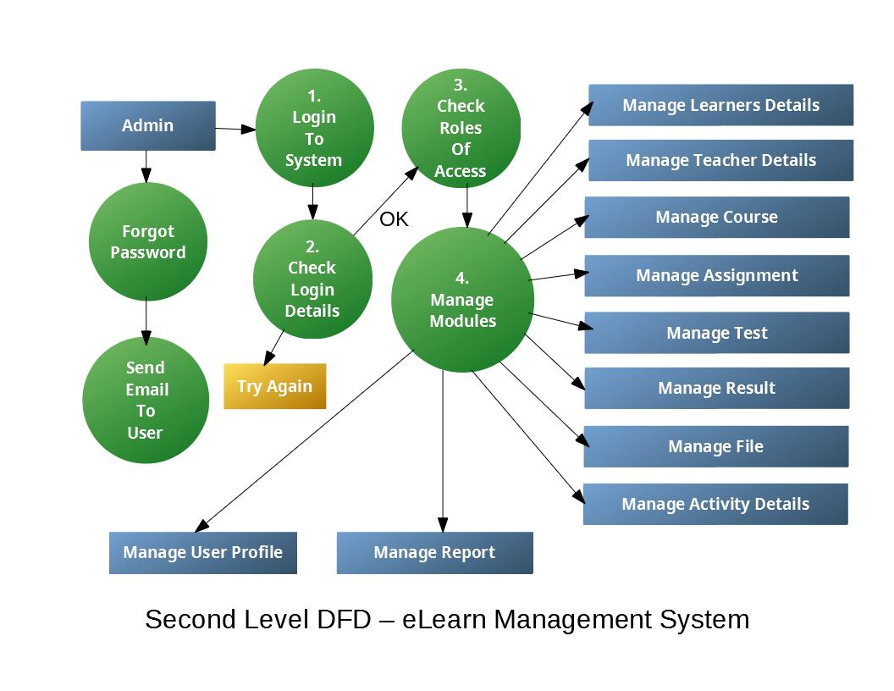

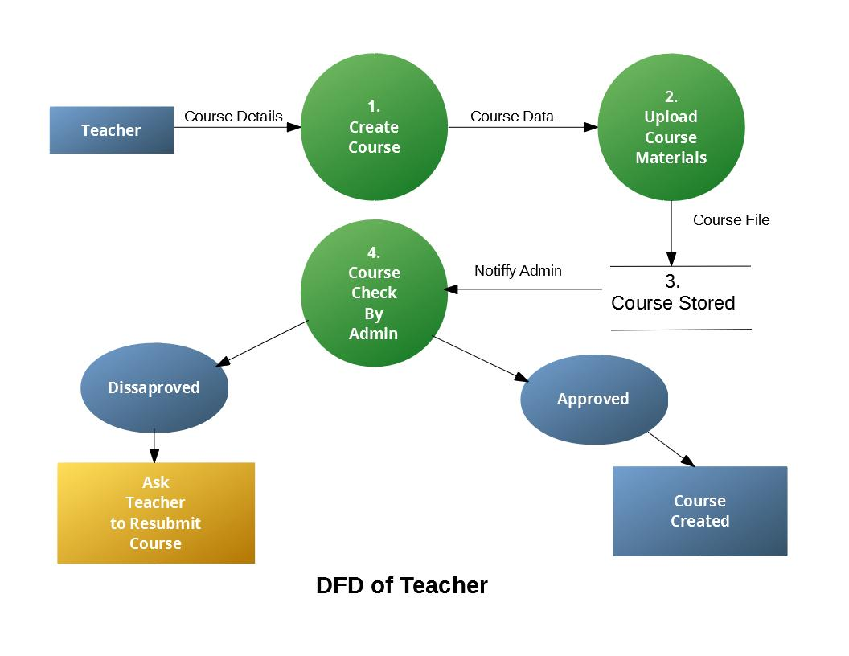

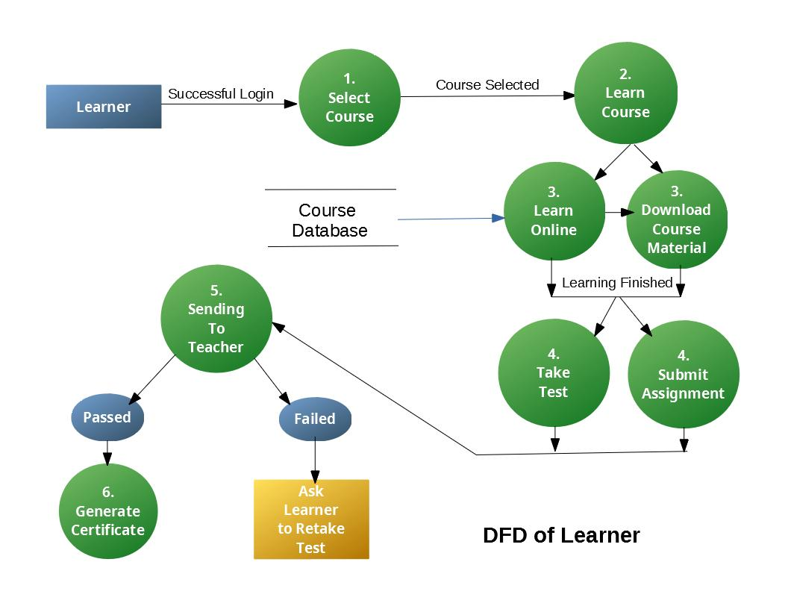

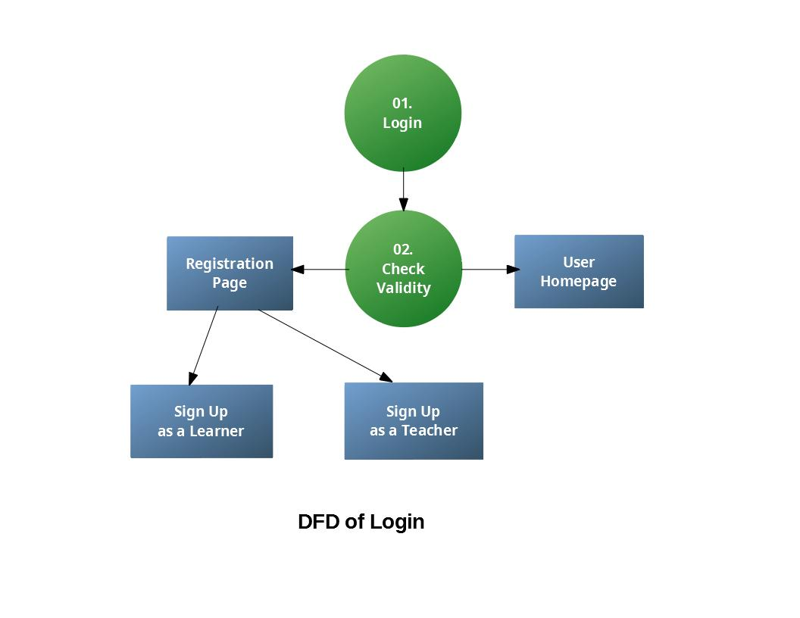

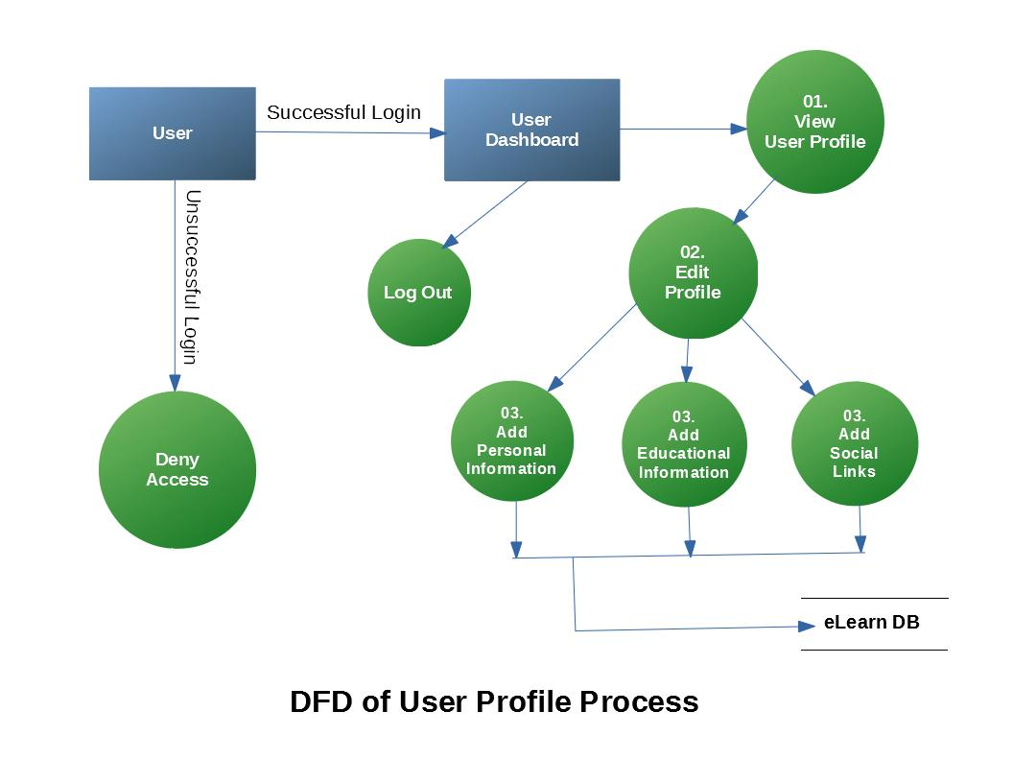

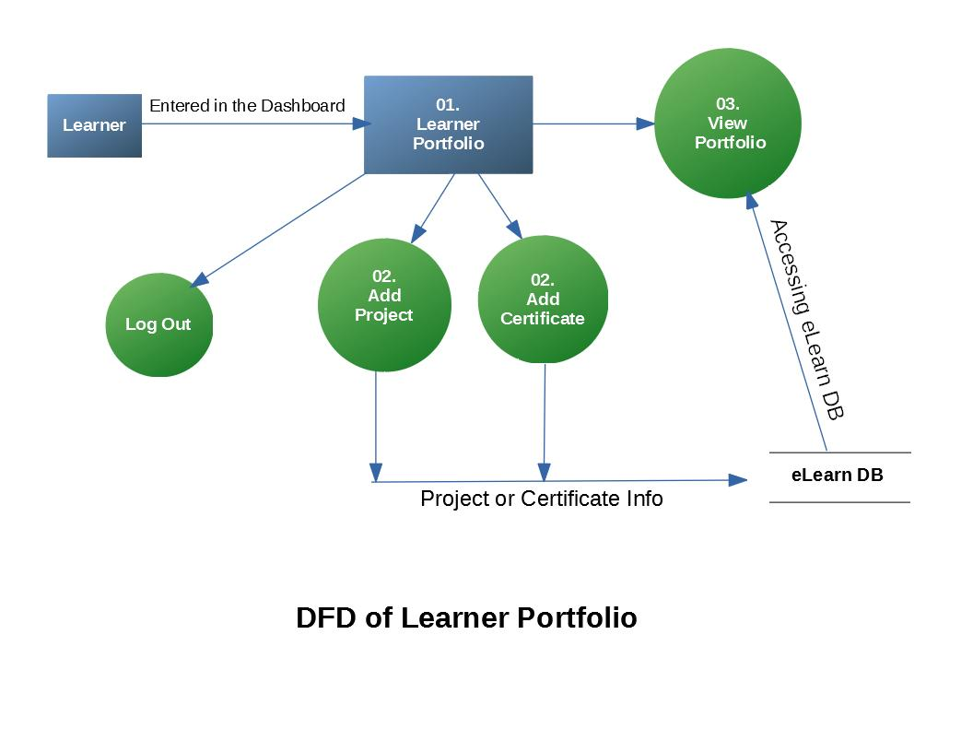

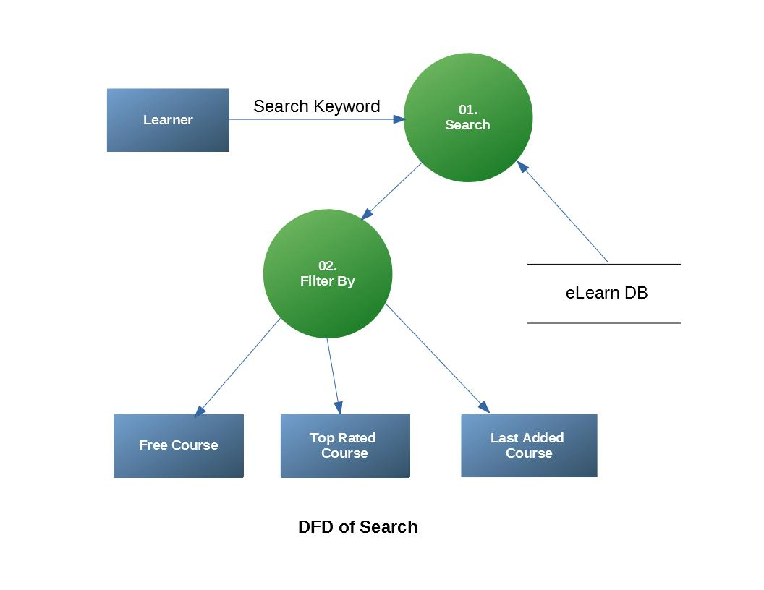

**Process Specification**

**Structured English:** Process **Login**

if login detail is correct

then

provide User Homepage

else

Provide registration page

if user clicks Sign Up as a Learner

then

Provide Learner Registration Page

else

if user clicks Sign Up as a Learner

then

Provide Teacher Registration Page

end if

end if

end if

**Decision Table:** Process Login

|  |  |  |  |
| --- | --- | --- | --- |
| **Condition** | **R1** | **R2** | **R3** |
| Login details is correct | Y | N | N |
| User clicked Sign Up as a Learner | - | Y | N |
| User clicked Sign Up a Teacher | - | - | Y |
|  |  |  |  |
| **Actions** |  |  |  |
| Provide User Homepage | X | - | - |
| Provide Registration Page for Learner | - | X | - |
| Provide Registration Page for Teacher | - | - | X |

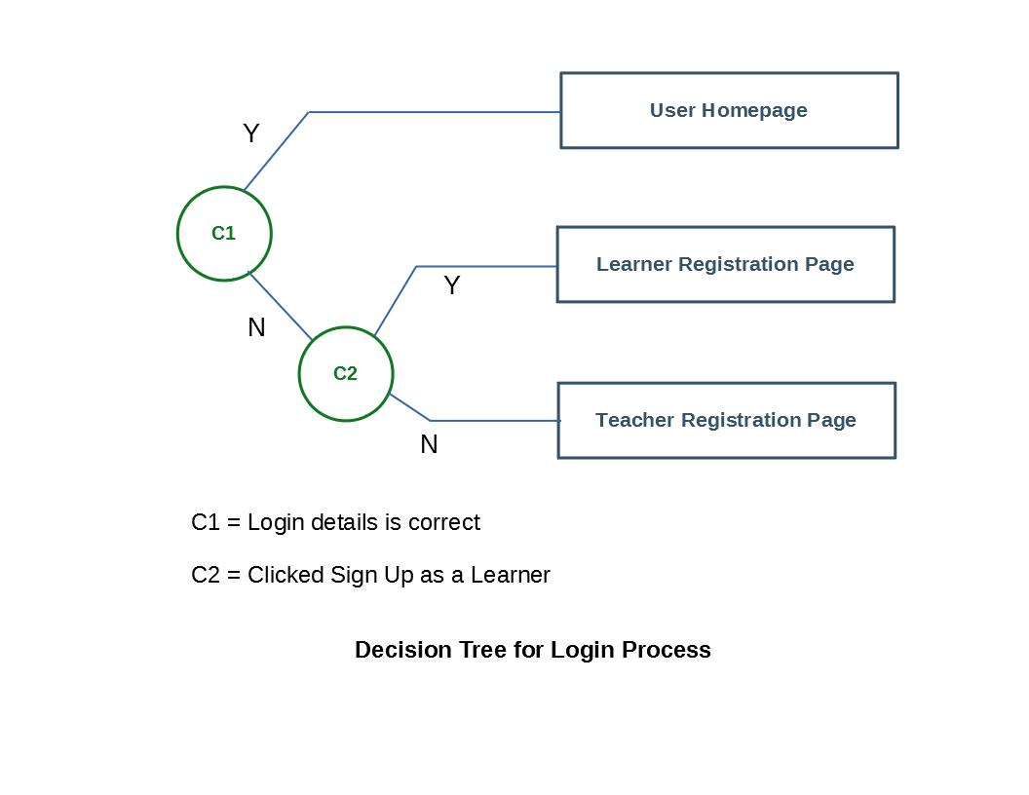

**Structured English:** Process **Admin Login**

if admin login detail is correct

then

if Roles of access checked out

then

Give access to Manage Modules

else

message try again

end if

else

if Forgot Password

then

Send Email to user

end if

end if

**Decision Table:** Process Login

|  |  |  |  |
| --- | --- | --- | --- |
| **Condition** | **R1** | **R2** | **R3** |
| Admin login details is correct | Y | N | N |
| Roles of access checked out | Y | N | N |
| Forgot Password | - | Y | N |
| Wring Password | - | - | Y |
|  |  |  |  |
| **Actions** |  |  |  |
| Give access to Manage Modules | X | - | - |
| Send Email to user | - | X | - |
| Message Try Again | - | - | X |
|  |  |  |  |

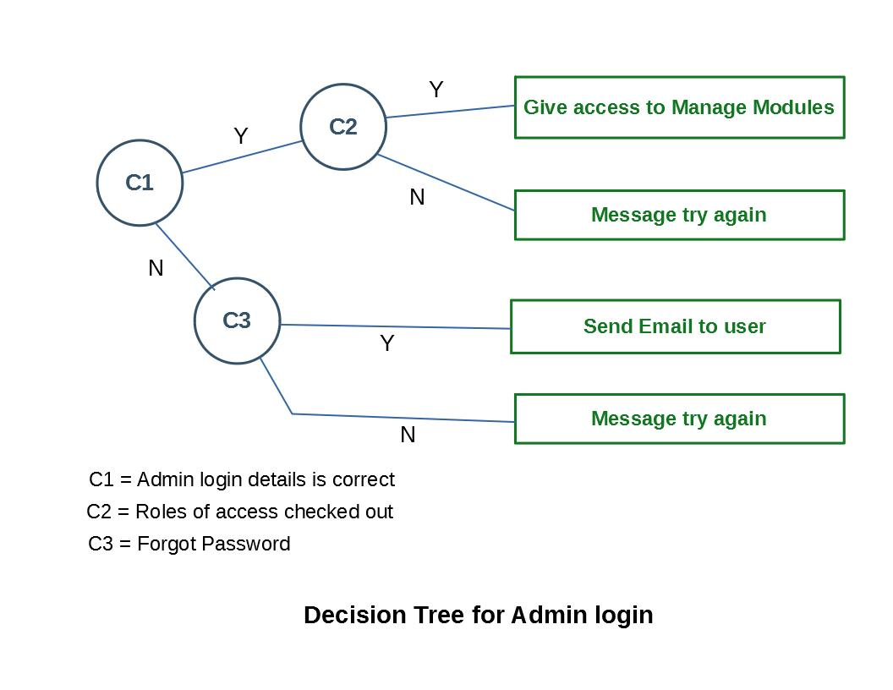

**Structured English:** Process Creating Course by Teacher

if Provided course details

then

if Uploaded course materials

then

if Checked out okay by admin

then

Approved Course

else

Disapproved course

end if

end if

else

Ask Teacher to try again

end if

**Decision Table:** Process Creating Course by Teacher

|  |  |  |  |
| --- | --- | --- | --- |
| **Condition** | **R1** | **R2** | **R3** |
| Provided Course Details | Y | Y | Y |
| Uploaded Course Materials | Y | Y | N |
| Check out okay by admin | Y | N | N |
|  |  |  |  |
| **Actions** |  |  |  |
| Approved Course | X | - | - |
| Disapproved Course | - | X | - |
| Ask Teacher to try again | - | - | X |

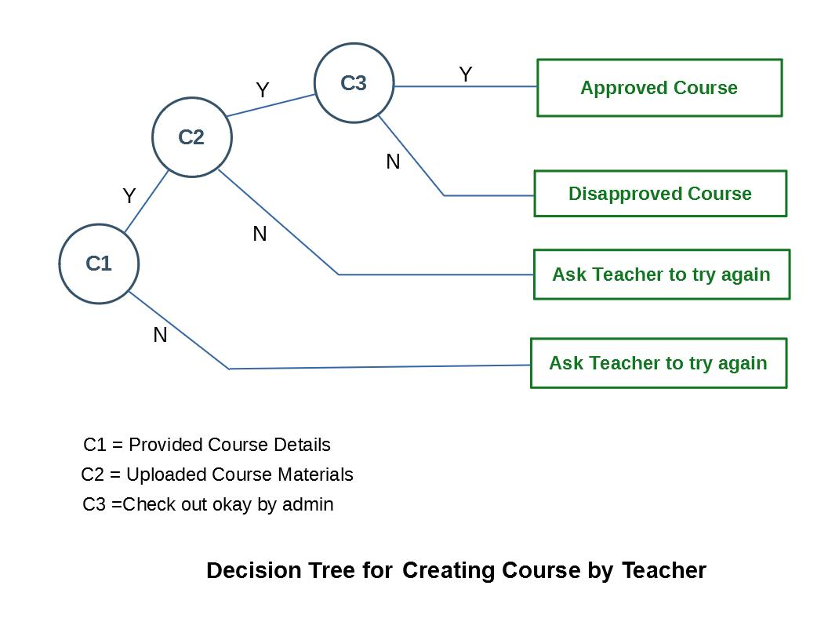

**Structured English:** Process Learning by Learner

if Login successful

then

if A course is selected

then

if Learning finished

then

if Passed the test

then

if Assignment submitted and approved

then

Generate Certificate

else Ask Learner to resubmit assignment

end if

else

Ask Learner to retake the Test

end if

else

Message Learner to try again

end if

end if

end if

**Decision Table:** Process Learning Course by Learner

|  |  |  |  |  |
| --- | --- | --- | --- | --- |
| **Condition** | **R1** | **R2** | **R3** | **R4** |
| Login successful | Y | Y | Y | Y |
| A course is selected | Y | Y | Y | Y |
| Learning finished | Y | Y | Y | N |
| Passed the Test | Y | N | Y | N |
| Assignment submitted and approved | Y | Y | N | N |
|  |  |  |  |  |
| **Actions** |  |  |  |  |
| Generate Certificate | X | - | - | - |
| Ask Learner to Retake Test | - | X | - | - |
| Ask Learner to resubmit assignment | - | - | X | - |
| Message Learner to try again | - | - | - | X |

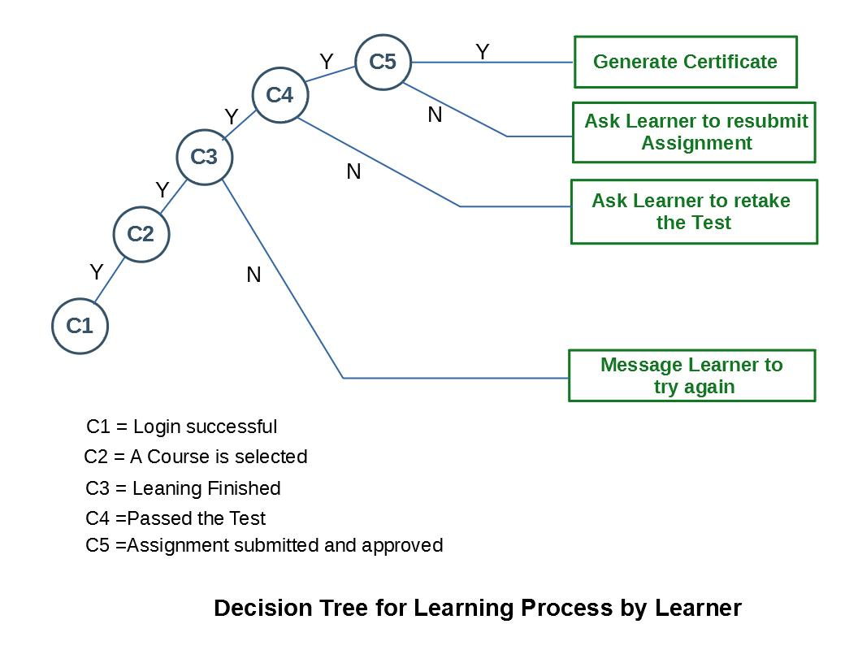

**Structured English:** Process **User Profile Management**

if User login successful

then

Provide User Dashboard

Provide permission to edit profile

Provide permission to add user information

else

Deny access

end if

**Decision Table:** Process User Profile Management

|  |  |  |
| --- | --- | --- |
| **Condition** | **R1** | **R2** |
| User Login Successful | Y | N |
|  |  |  |
| **Actions** |  |  |
| Provide User Dashboard | X | - |
| Provide permission to edit profile | X | - |
| Provide permission to add user information | X | - |
| Deny access | - | X |

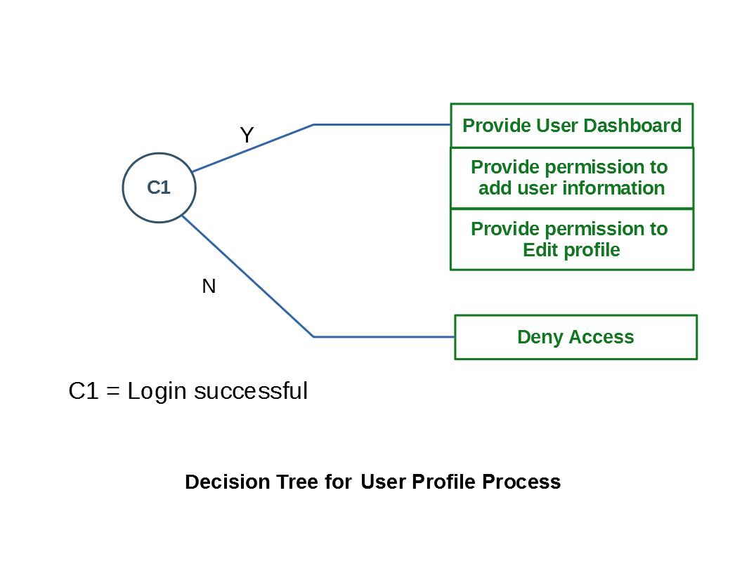

**Structured English:** Process **Learner Portfolio**

if User entered the Dashboard

then

Provide access to Learner Portfolio

Provide permission to add project

Provide permission to add certificate

else

Deny access

end if

**Decision Table:** Process **Learner Portfolio**

|  |  |  |
| --- | --- | --- |
| **Condition** | **R1** | **R2** |
| User entered the Dashboard | Y | N |
| **Actions** |  |  |
| Provide access to Learner Portfolio | X | - |
| Provide permission to add project | X | - |
| Provide permission to add certificate | X | - |
| Deny access | - | X |

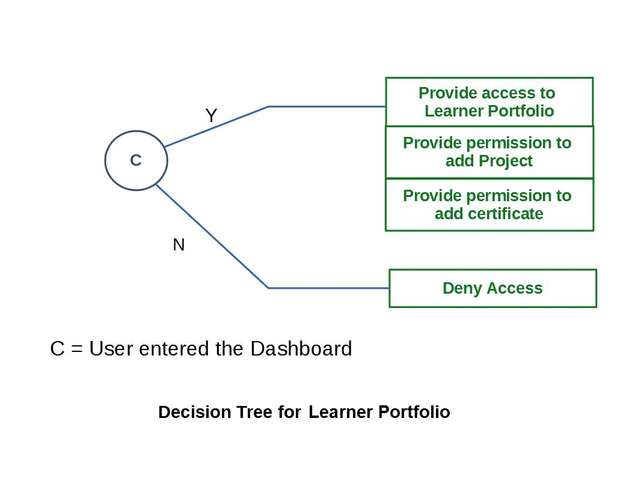

**Structured English:** Process **Searching Course**

if User entered search keyword

then

Provide Matched Courses with the Keyword

else

if Filter by Free Course

then

Provide All Free Courses

else

if Filter by Top-Rated Course

then

Provide All Top-Rated Courses

else

if Provide All Last Updated Courses

Then

Provide All Last Updated Courses

else

if just clicked Search

then

Provide all courses

else

No action

end if

**Decision Table:** Process **Searching Course**

|  |  |  |  |  |  |
| --- | --- | --- | --- | --- | --- |
| **Condition** | **R1** | **R2** | **R3** | **R4** | **R5** |
| User entered search keyword | Y | N | N | N | N |
| Filter by Free Course | - | Y | N | N | N |
| Filter by Top-Rated Course | - | - | Y | N | N |
| Filter by Last Updated Course | - | - | - | Y | N |
| Just Clicked Search | - | - | - | - | Y |
| **Actions** |  |  |  |  |  |
| Provide Matched Courses with the Keyword | X | - | - | - | - |
| Provide All Free Courses | - | X | - | - | - |
| Provide All Top-Rated Courses | - | - | X | - | - |
| Provide All Last Updated Courses | - | - | - | X | - |
| Provide All Courses | - | - | - | - | X |

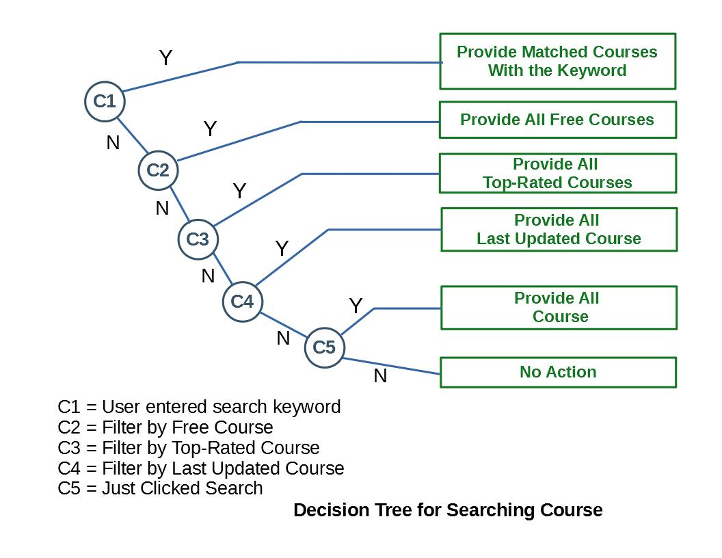

**Conclusion**

The problem of the existing learning/education system has been successfully studied and Also the future system is planned to solve those problems and designed in a teaching and learning process what made concentration of different abilities possible:

* Unlimited space content distribution and all-time access to learning contents
* Ability to follow and register students’ work and check their knowledge
* Different forms of communication and management among the users
* Ability to organize and manage different study programs

It was shown that the system is useful for preparing the students for teaching, a reminder on learning material, as a means to give practical tasks in digital form and gathering solution and online tests realization. Also provide learner the best options to learn.

In conclusion, to this research project I find that to develop a fully working system is not only a difficult task but also requires a lot of knowledge in database design and programming languages. I wish I could develop the system I had in my mind.

It would be very helpful if the Universities and schools all over the world could concentrate on this subject to make this project real and it would help people all over the world.

Also, instead of teacher useless subject the university could teach us JavaScript, PHP and the other languages that are used when developing an online system.

Finally, I would like to express myself as to how I find this process of developing a system to be very awaking to the mind of a student and to learn how to and teach themselves things. I have built a skill of how to search for things and develop then to my needs.

It has indeed, been a great experience. For this reason. I am grateful to my teachers.